 ONE BOARD TO RULE THEM ALL

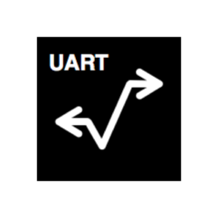

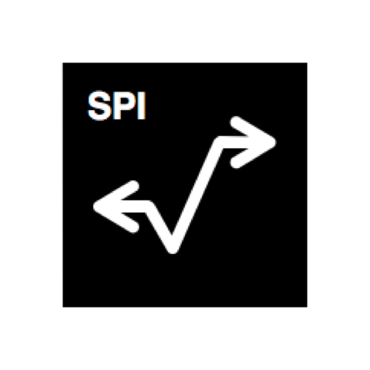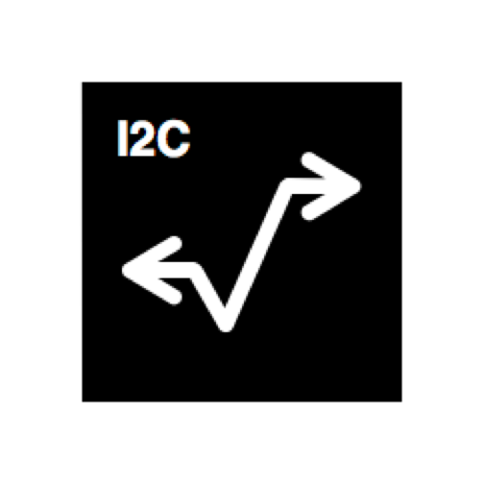

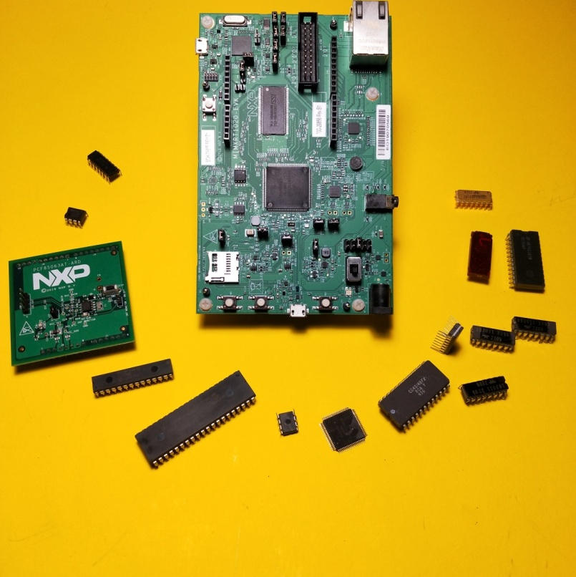

Project name : IMX - MULTIPROTOCOL

Maker : Stulin Enrico – enrico.stulin@gmail.com

Necessary Hardware: Just NIMXRT1020-EVK + 1xMicro USB cable

Complexity: Very simple

Introduction:

The IMX Multiprotocol for NIMXRT1020-EVK is an embedded software solutions that allows you to transfer data from USB to all the main digital interfaces - UART, I2C and SPI.This project will help you to analyze and debug all the main digital and analog IC’s as well as lot of IOT and RF demoboard, saving you the time to develop a custom firmware, or buying expensive data converters.